**JUnit Testing Exercises**

**Exercise 1: Setting Up JUnit Scenario: You need to set up JUnit in your Java project to start writing unit tests.**

Steps:

1. Create a new Java project in your IDE (e.g., IntelliJ IDEA, Eclipse).

2. Add JUnit dependency to your project. If you are using Maven, add the following to your pom.xml: junit junit 4.13.2 test

3. Create a new test class in your project.

**OUTPUT:** 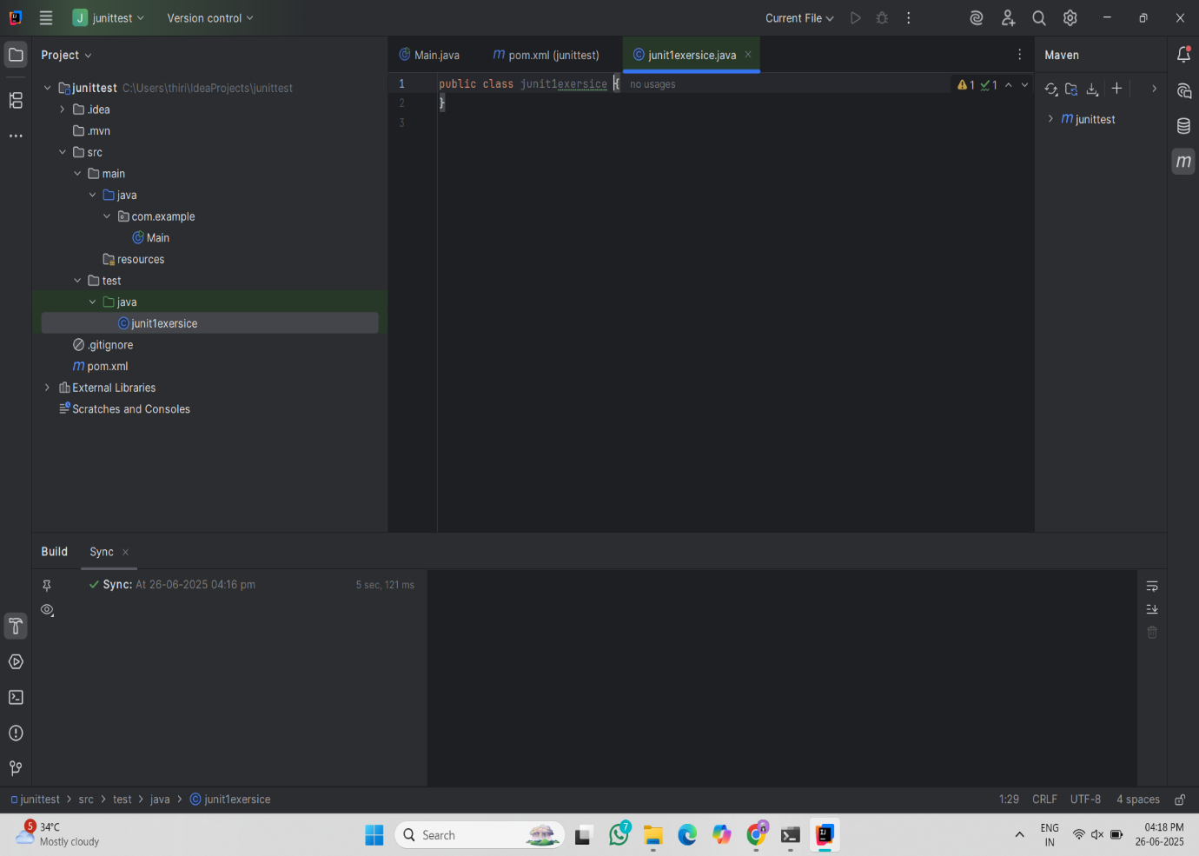

**Exercise 2: Writing Basic JUnit Tests Scenario:**

You need to write basic JUnit tests for a simple Java class.

Steps:

1. Create a new Java class with some methods to test.

2. Write JUnit tests for these methods.

**SOLUTION:**

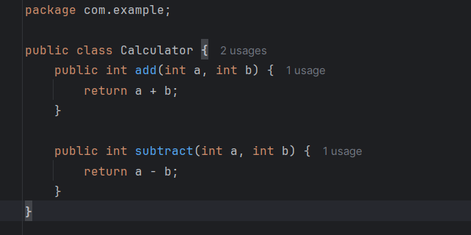

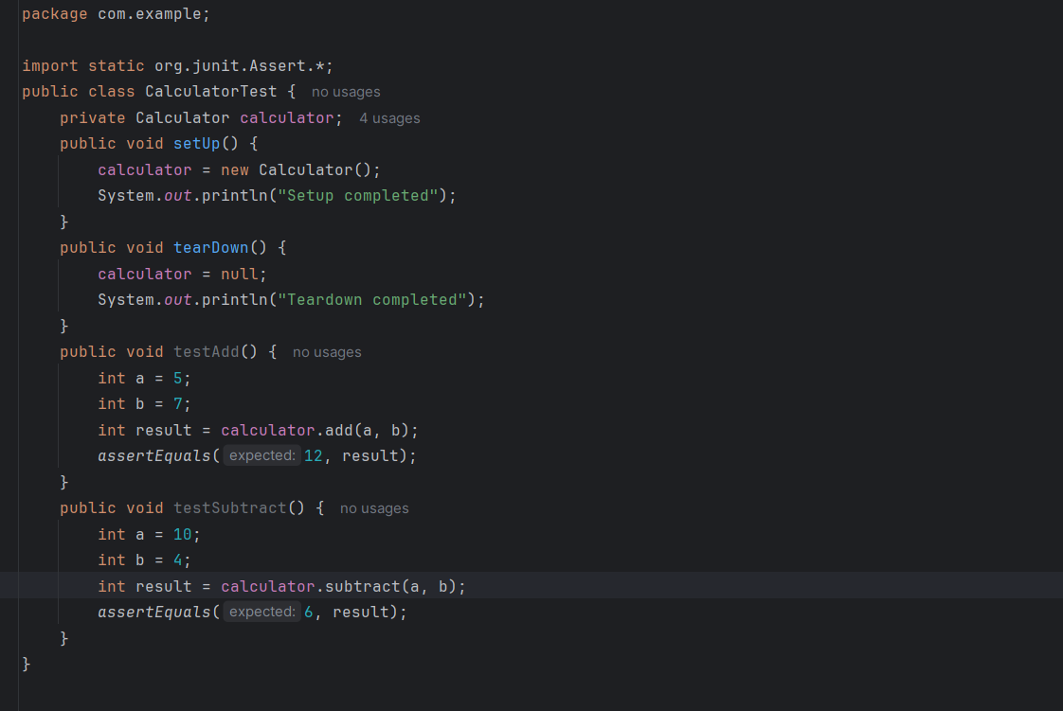

**OUTPUT:**

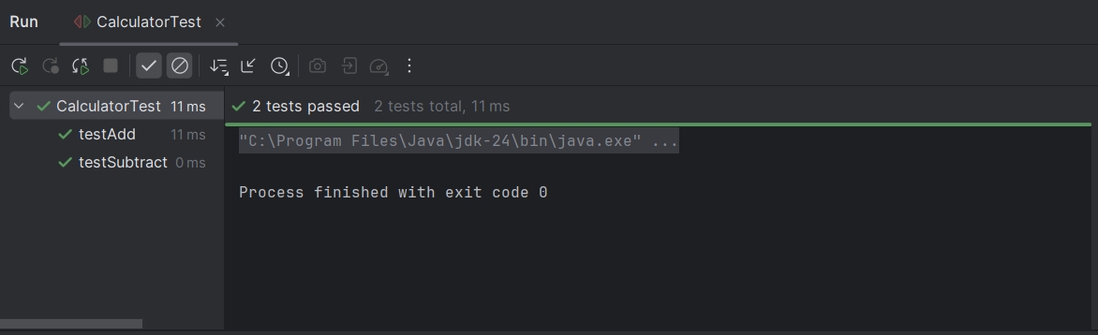

**Exercise 3: Assertions in JUnit Scenario:**

You need to use different assertions in JUnit to validate your test results.

Steps: 1. Write tests using various JUnit assertions.

Solution Code:

public class AssertionsTest {

@Test

public void testAssertions() {

// Assert equals

assertEquals(5, 2 + 3);

// Assert true

assertTrue(5 > 3);

// Assert false

assertFalse(5 < 3);

// Assert null

assertNull(null);

// Assert not null

assertNotNull(new Object());

}

}

**SOLUTION:**

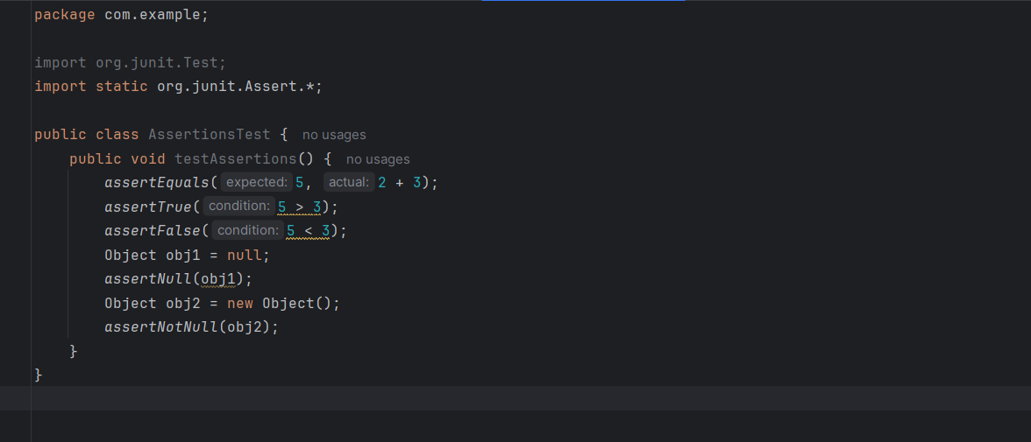

**OUTPUT:**

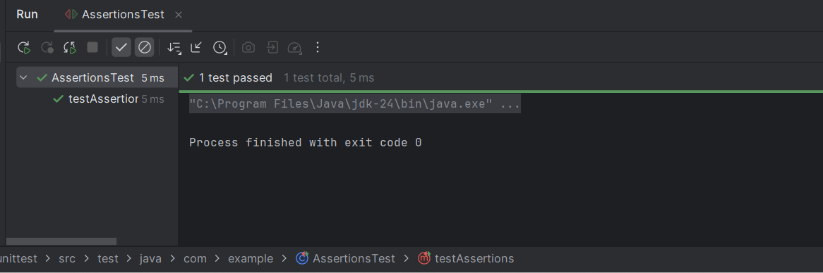

**Exercise 4: Arrange-Act-Assert (AAA) Pattern, Test Fixtures, Setup and Teardown Methods in JUnit**

Scenario:

You need to organize your tests using the Arrange-Act-Assert (AAA) pattern and use setup and teardown methods.

Steps: 1. Write tests using the AAA pattern.

2. Use @Before and @After annotations for setup and teardown methods.

**SOLUTION:**

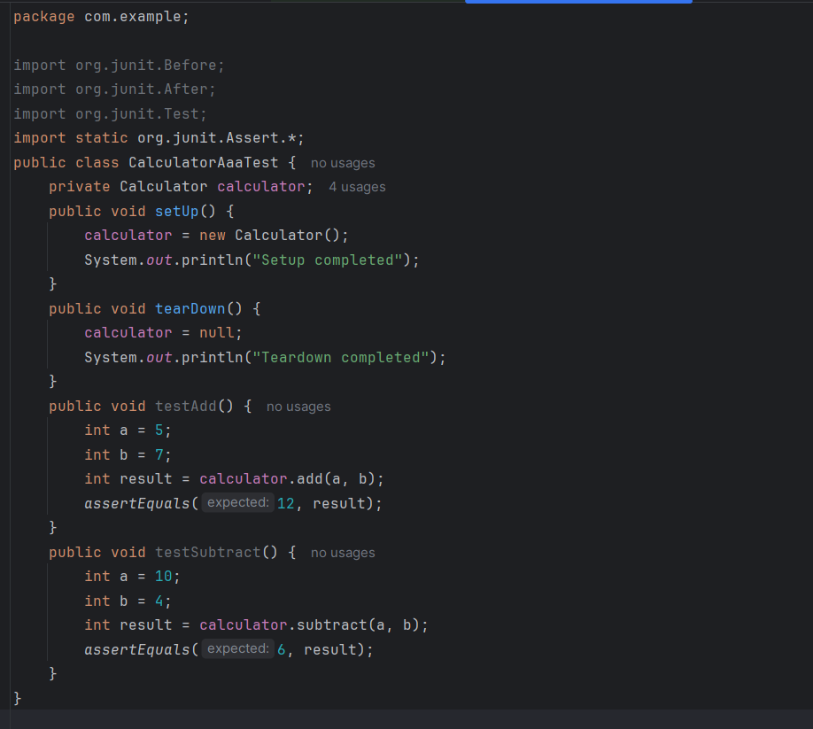

**OUTPUT:**

